**RUN DATABASE**

1. Open MongoDB App
2. Select **localhost:27017**
3. Click on **connect** button

………………………………………………………………

**RUN BACKEND**

1. Open Visual Studio
2. Check if on Window 1 or

Window 2 (realise.yami - csi-api - Visual Studio Code)

**In Window 2**

OPTIONAL

1. Click **File** tab > **New Window**
2. In window terminal, click **File** tab > **Open Folder**
3. In the pop up file folder, go to **Document** folder > select **csi-api** folder C:\Users\aidal\OneDrive\Documentos\csi-api
4. Click on select folder

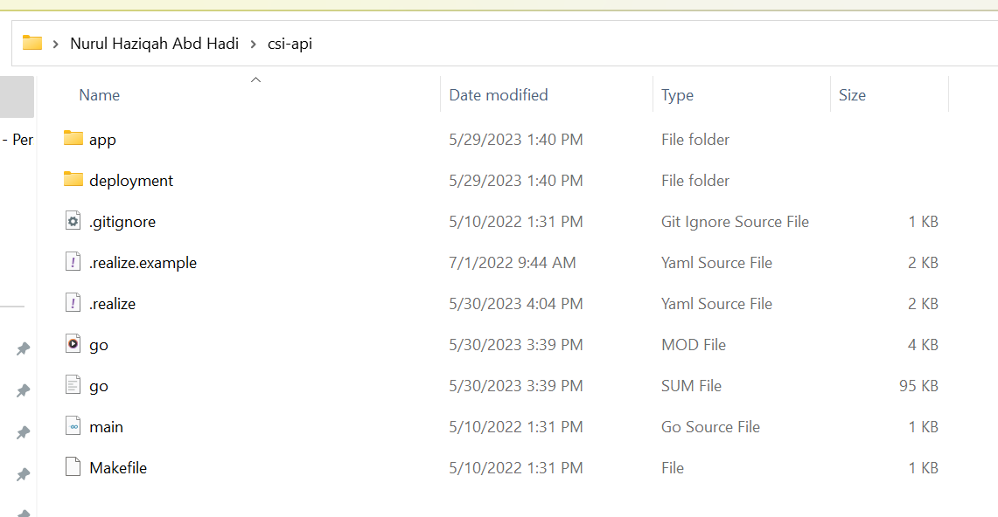

1. Go **Terminal** tab > **New terminal**

Execute command

1. Type on terminal - **go run .\main.go**
2. Press **Enter** on keyboard

**In Window 1**

1. In new window, click **File** tab > **Open Folder**
2. In the pop up file folder, go to **Aida-CSI** folder > double click on **csi-test** folder

C:\Aida - CSI\localhost - test site\CSI-test\CSI-test

1. Click on select folder

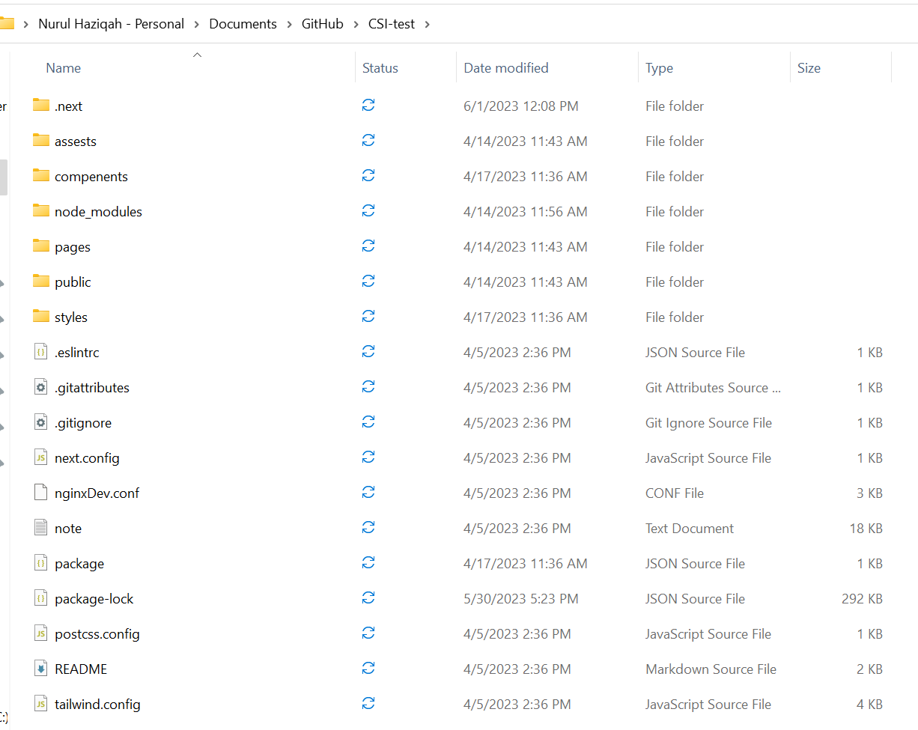

1. Go **Terminal** tab > **New terminal**

Execute command

1. Type on terminal – **npm run dev**
2. Press **Enter** on keyboard

OPTIONAL: In case does not work,

Run command - npm run build

………………………………………………………………

**LAUNCH BROWSER**

1. Go to browser and type <http://localhost:3000>
2. You suppose to land at registration page

Admin portal

<http://localhost:3000/admin/login>

[tesQQt6@gmail.com](mailto:tesQQt6@gmail.com)

1231123

SME

[aidalim1@csi-asean.com](mailto:aidalim1@csi-asean.com)

1234CsiSB

Portfolio

[nurul.haziqah@csi-asean.com](mailto:nurul.haziqah@csi-asean.com)

1234CsiP